Our company develop advanced Smart Water Management System, which combines the usage of a network of sensor devices and sophisticated Machine Learning capability to better manage water quality and consumption, typically in <agriculture, residents, urban utility… >.

**How system work**:

The entry point of our solution is a portfolio of advanced and polyvalent IoT devices, researched and developed by our hardware team, which composed of tightly packed sensors and circuit boards. They will be installed on key part of water distribution infrastructure (such as pumps and pipes joints). As part of our holistic approach, the devices can track parameters at all level of the watering system: from environment (light, moisture), water volume and quality, down to the physical state of the piping networks. The collected data is sent in real time to a Cloud servers, where they are processed by our ML algorithms to build up a high-definition pattern map of water usage. This map is continually refined as more data is processed, and allows us to:

* Making better prediction of water needs in function of time, weather, usage context, helping to optimize volume allocation, especially in scarce water region.
* This help detect and prevent all types of incidents at each level of the water infrastructure (over consumption, abnormal water quality, water leakage, pipe degradation and breakdown). Thanks to the high sensitivity of our devices and sophisticated pattern detection algorithm, our system is capable of monitoring the slightest change in the state of water network and send notification in a timely manner. This capability is critical by preventing all possible costly incidents, which my go unnoticed under less-advanced monitoring system.

Our solution comprises also a software interface, including clearly-organized monitoring dashboard, and easy-to-use control interface, allowing user to configure the system to suit their needs.

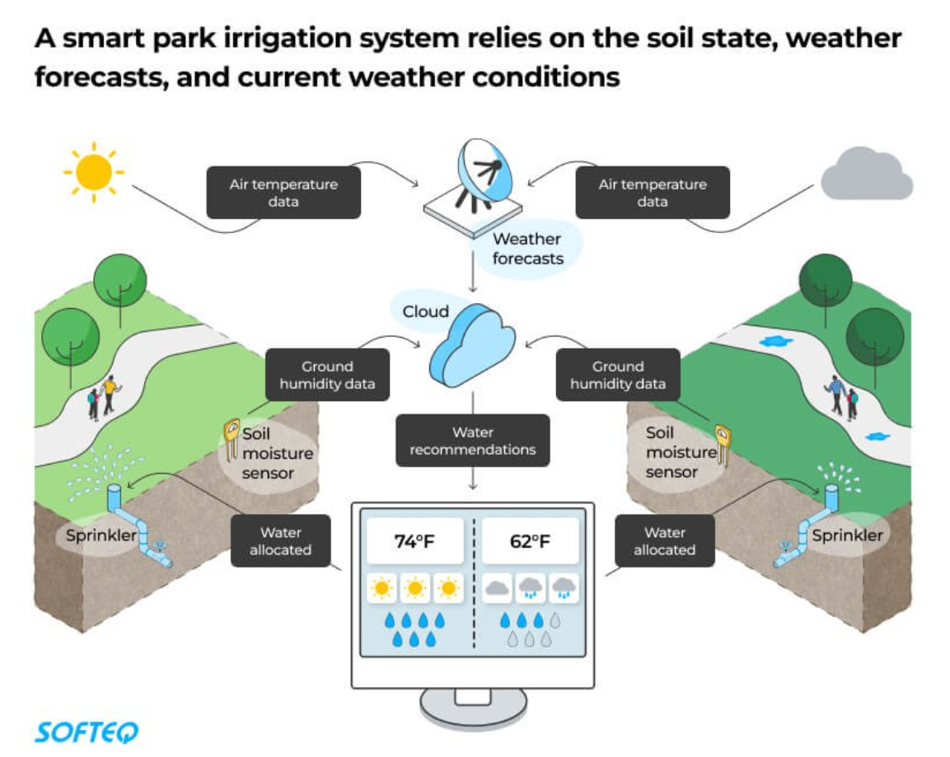

**Example of the deployment of smart system in Irrigation System in dry region**: our system helps create moisture map of the chosen areas and can send signals to the irrigation system. Thanks to continuous monitoring of soil moisture and weather condition, water is delivered only when required in rightly calibrated volume, ensuring optimized use of water resource and efficient irrigation.

Other advantages of our solution compared to current market state:

* Current market sensors tend to have mediocre signal reach, limiting the boundary of real time data exchange. We have found solution to double our sensors reach, providing far higher coverage surface per sensor than competitor.
* We have chosen Our polyvalent devices, packed with multiple sensors, simplify installation and maintenance task, thus reducing those costs by 30% compared to installing all sensors separately